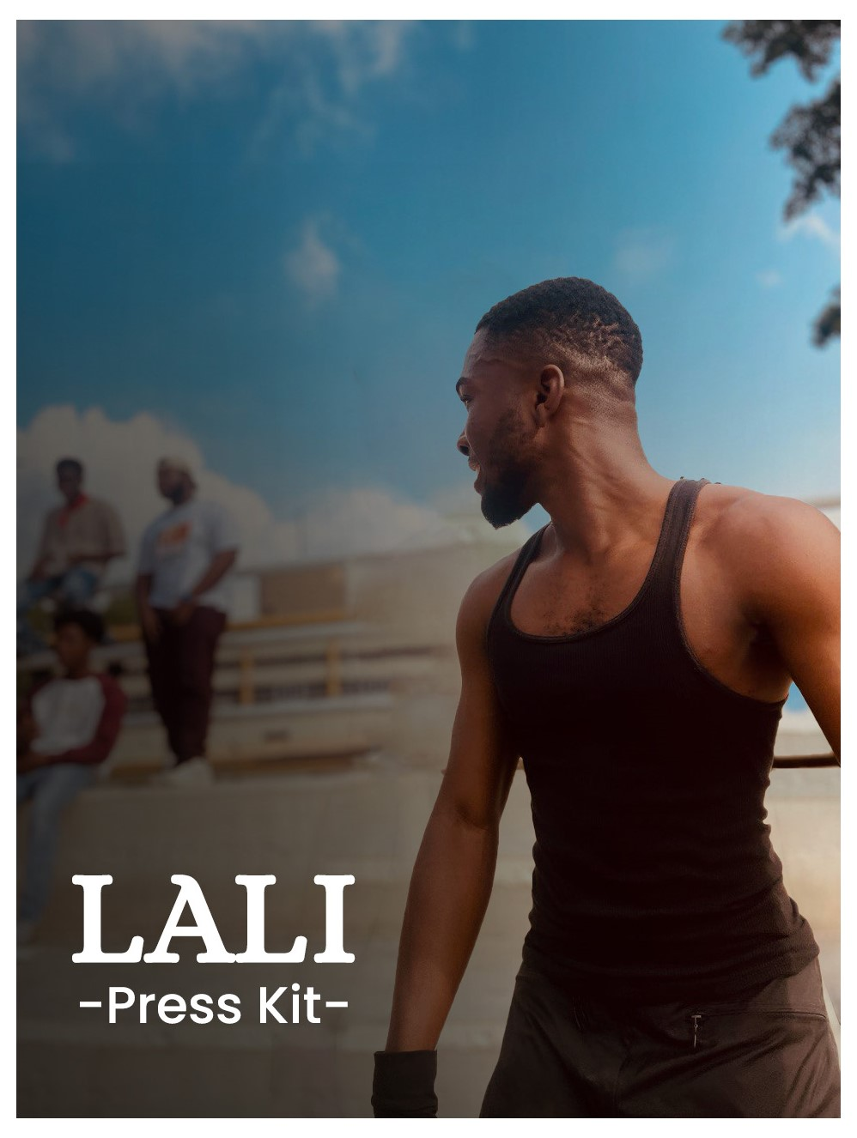

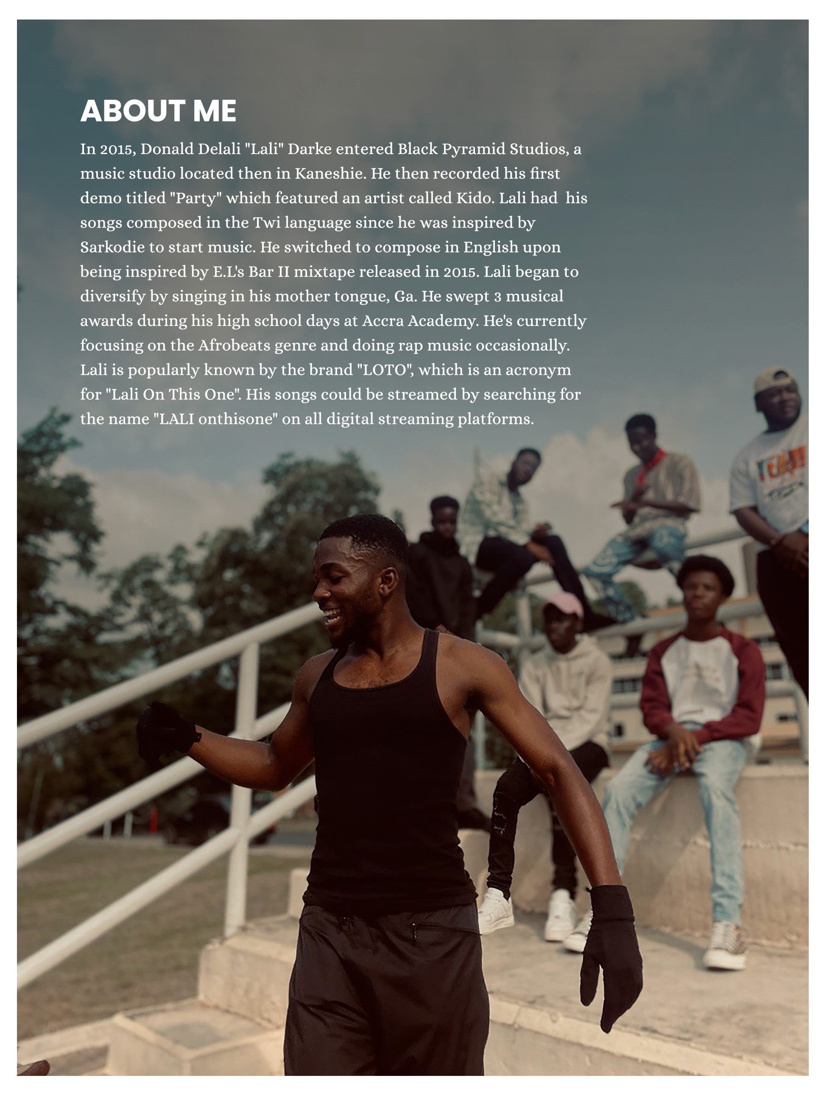

ABOUT MY MUSIC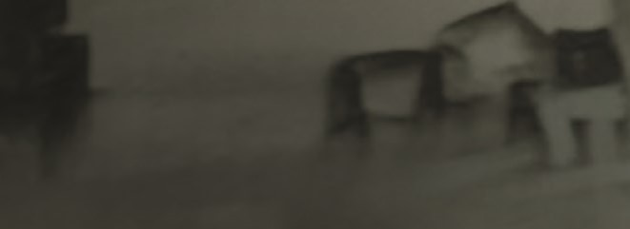

PROJECTS

OFFICIAL MUSIC VIDEOS

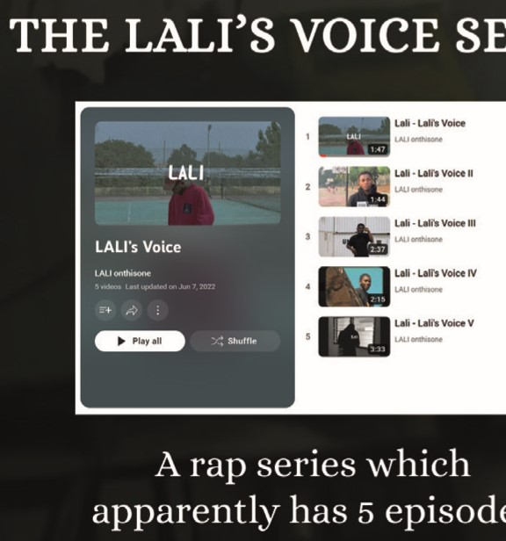

SERIES

episodes.

(om•l

v• video)

Official Music Videos

play

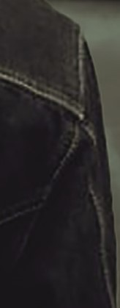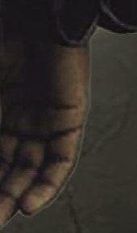Official music videos for my singles, Wavy and Mind Games.

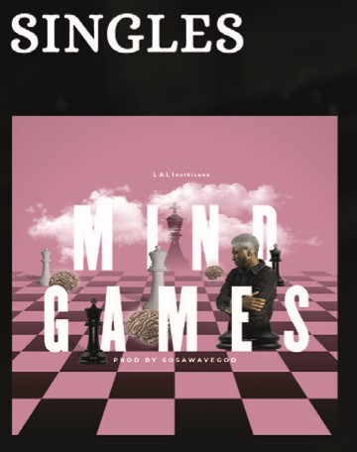



Mind Games - 2020 Wavy ft. Cool V - 2021 Brotherzone - 2022 Rent-Free - 2022



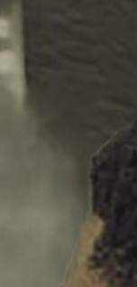

QUALITY

# 1.07.ot.C1'

Quick One - 2022

Lali won The Rap League competition hosted by YFM, Kumasi.

(Tech) 17 SEPT1 Fri

Þy1025fm

# ROUND 1

LYRICAL MUGABY

(Bantama) 01 Oct 1 Fri (Tech.)

ROUND 3

(Awamaso) 24 SEPT1 Fri (Tech.)

# ROUND 2

(Kwadaso) 08 Oct 1 Fri (Tech,)

@y102Sfm

# FINAL ROUND

